

Name : Y.Manoj kumar Course name : 5Gand6G Communicaton Registration num:1912260567 Course code : ECA5610
Experiment Number: 3
MATLAB Analysis of Spectrum Bands, Propagation Loss and Cellular Interference

Aim:
To compare a simplified free-space path-loss estimate across representative sub-1 GHz, mid-band and mmWave frequencies, and examine how distance and frequency reuse affect received signal and a simple interference measure.
Objectives
By the end of the experiment, students should be able to:
1. Calculate or simulate path loss at representative sub-1 GHz, mid-band and mmWave frequencies.
2. Compare estimated received signal strength as frequency and distance change.
3. Examine how cell separation or frequency reuse changes a simplified interference ratio.
4. Relate the results to coverage and spectrum-use considerations across mobile generations, while stating model limitations.
Requirements
Computer with MATLAB R2019b or later.
No RF hardware is required.
Theoretical Background
The free-space path-loss equation in decibels is FSPL = 32.44 + 20log₁₀(f_MHz) + 20log₁₀(d_km), where f is carrier frequency and d is separation. With fixed transmit power and antenna gains, estimated received power is P_r = P_t + G_t + G_r − FSPL. In this idealized equation, doubling distance adds about 6 dB of loss and doubling frequency adds about 6 dB of loss at the same distance.
For a simple reuse illustration, let the desired transmitter be at distance R and six equal-power co-channel interferers be at distance D = √(3N)R, where N is a reuse-cluster size. Under a power-law path-loss exponent n, approximate SIR = (D/R)^n / 6. This idealized first-tier model omits shadowing, fading, sector antennas, unequal loads, terrain, adjacent-channel leakage and real frequency-planning constraints. Because desired and interfering links use the same frequency, frequency-dependent free-space loss cancels in this simplified SIR ratio.
Parameters and Assumptions
Parameter | Baseline value | Meaning
Carrier bands | 0.7, 3.5, 28 GHz | Representative sub-1 GHz, mid-band and mmWave points
Transmit power | 30 dBm | Illustrative conducted power; antenna gains set to 0 dBi
Distance range | 0.1 to 2 km | Free-space comparison range
Path-loss exponent for reuse model | 3.5 | Illustrative non-free-space distance exponent
Reuse cluster sizes N | 1, 3, 7, 12 | Larger N implies greater idealized co-channel separation

These are teaching assumptions, not regulatory limits or recommended deployment settings. The free-space curve is not an urban, indoor or mmWave channel model.
Procedure
1. Run the script and inspect the path-loss and received-power plots.
2. Record the estimated received power at 0.5 km for each frequency.
3. Inspect the reuse-SIR plot and compare the baseline N values.
4. Change transmit power, distance range, path-loss exponent or reuse sizes; rerun and record the effect.
5. Explain why frequency reuse changes the simplified co-channel SIR and why the free-space link budget is not a complete coverage prediction.
MATLAB Program — Path Loss, Received Power and Reuse Interference
% Experiment 3: illustrative propagation and frequency reuse

clear; clc; close all;
% Representative bands and link-budget assumptions
freqGHz = [0.7 3.5 28];
freqMHz = freqGHz * 1000;
bandName = ["Sub-1 GHz"; "Mid-band"; "mmWave"];
txPowerdBm = 30;
gtDbi = 0; grDbi = 0;
distanceKm = logspace(log10(0.1),log10(2),200);
distanceAtPointKm = 0.5;

% Free-space path loss (d in km, f in MHz)
fspl = @(fMHz,dKm) 32.44 + 20*log10(fMHz) + 20*log10(dKm);
lossAtPoint = fspl(freqMHz,distanceAtPointKm);
rxAtPoint = txPowerdBm + gtDbi + grDbi - lossAtPoint;
linkTable = table(bandName,freqGHz(:),lossAtPoint(:),rxAtPoint(:), ...
'VariableNames',{'Band','Frequency_GHz','FSPL_dB','EstimatedRx_dBm'});
disp(linkTable);

% Path loss and received power over distance
figure; tiledlayout(1,2);
nexttile; hold on; grid on;
for k=1:numel(freqMHz)
plot(distanceKm,fspl(freqMHz(k),distanceKm),'LineWidth',1.5);
end
set(gca,'XScale','log'); xlabel('Distance (km)'); ylabel('Path loss (dB)');
legend(bandName,'Location','northwest'); title('Free-Space Path Loss');
nexttile; hold on; grid on;
for k=1:numel(freqMHz)
rx = txPowerdBm + gtDbi + grDbi - fspl(freqMHz(k),distanceKm);
plot(distanceKm,rx,'LineWidth',1.5);
end
set(gca,'XScale','log'); xlabel('Distance (km)'); ylabel('Estimated received power (dBm)');
legend(bandName,'Location','southwest'); title('Illustrative Received Power');

% Simple first-tier co-channel reuse estimate
cellRadiusKm = 0.5;
reuseN = [1 3 7 12];
pathLossExponent = 3.5;
reuseDistance = sqrt(3*reuseN) * cellRadiusKm;
sirLinear = (reuseDistance/cellRadiusKm).^pathLossExponent / 6;
sirDb = 10*log10(sirLinear);
reuseTable = table(reuseN(:),reuseDistance(:),sirDb(:), ...
'VariableNames',{'ReuseClusterN','ApproxInterfererDistance_km','ApproxSIR_dB'});
disp(reuseTable);
figure; plot(reuseN,sirDb,'o-','LineWidth',1.5); grid on;
xlabel('Reuse cluster size N'); ylabel('Approximate SIR (dB)');
title('Simplified Co-Channel SIR versus Reuse Cluster Size');

fprintf('At %.2f km, estimated received powers are:\n',distanceAtPointKm);
disp(table(bandName,rxAtPoint(:),'VariableNames',{'Band','Rx_dBm'}));
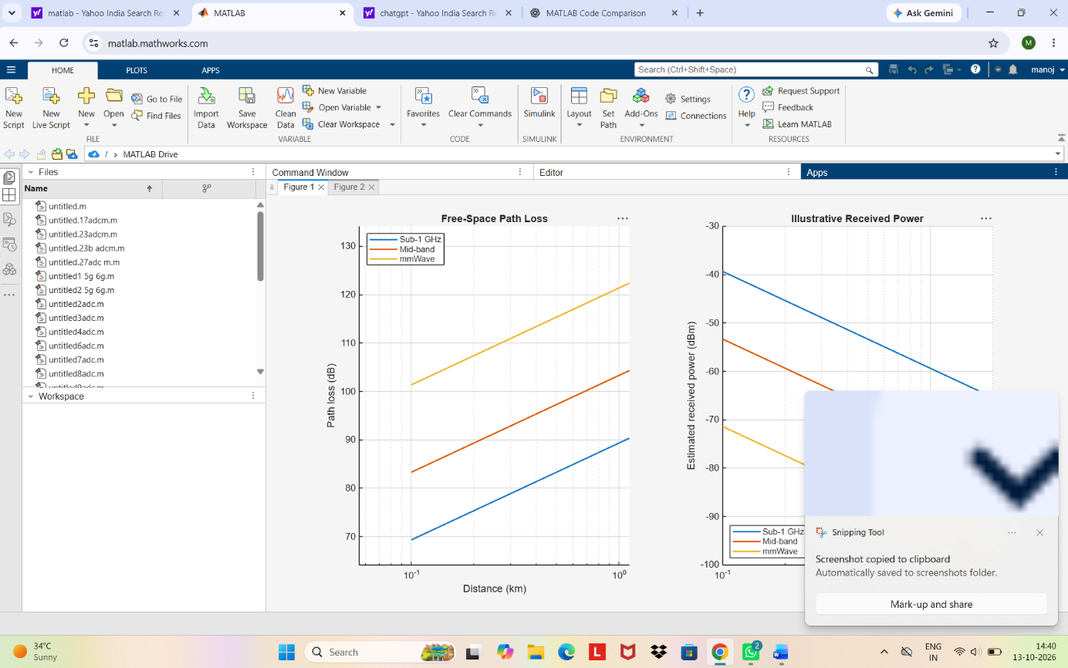
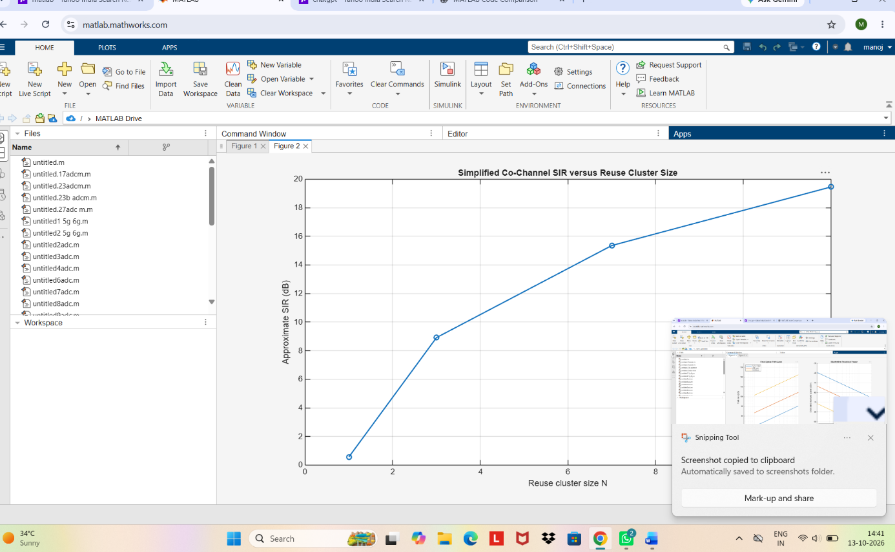

Results to Record
Band | Frequency (GHz) | FSPL at 0.5 km (dB) | Estimated Rx (dBm)
Sub-1 GHz | 0.7 | ___83.321_____ | ____-53.321____
Mid-band | 3.5 | ___97.301 | ____-67.301
mmWave | 28 | ___115.36__ | ____-85.363____

Reuse N | Interferer distance (km) | Approx. SIR (dB)
1 | ________0.86603 | __0.56811______
3 | ________1.5 | __8.9177___
7 | ________2.2913 | __15.357______
12 | ________3 | __19.454

Analysis Questions
1. At a fixed distance, which representative band has the highest free-space loss? Explain the frequency term in the equation.
2. How does doubling distance affect FSPL in this model?
3. What trend does the reuse-SIR estimate show as N increases, and which geometric assumption drives that trend?
4. Why should the calculated received power not be treated as a reliable coverage radius for an actual cellular system?
5. Relate the bands qualitatively to coverage and capacity trade-offs without treating this simple model as a comparison of complete mobile generations.
Conclusion
Summarize the frequency and distance trends from the simulation and the effect of reuse separation on the illustrative SIR. Identify the free-space assumption, fixed transmit power and idealized six-interferer geometry as limitations. Note that practical coverage depends on antenna characteristics, environment, bandwidth, receiver sensitivity, interference, regulatory constraints and the chosen propagation model.
Assessment Rubric — Experiment 3
Criterion | Weight | 4 — Strong | 3 — Meets | 2 — Partial | 1 — Limited
Path-loss and received-power calculations | 25 | Correct units, calculations and band comparison | Mostly correct with minor error | Some calculations or interpretation incorrect | Calculations missing or substantially wrong
Distance/frequency plots | 20 | Clear labeled plots and trends explained | Plots mostly correct | Plot or labels incomplete | Plots missing or unusable
Reuse interference analysis | 20 | Correct model and trend interpretation | Minor error or explanation gap | Partial calculation or weak interpretation | Analysis missing or incorrect
Parameter study and analysis | 15 | Relevant changes and evidence-based discussion | Rerun mostly complete | Limited comparison | No meaningful parameter study
Conclusion and model limitations | 15 | Accurate conclusion with clear limitations | Reasonable conclusion, a limitation omitted | Mostly repeats output | Unsupported claim or missing conclusion
Report and individual explanation | 5 | Organized evidence; equations explained | Minor gaps | Evidence or explanation incomplete | Report unclear or unable to explain

